The HAMBURGER RUBRIC
Four friends go to a restaurant. Each of them orders a hot, fresh hamburger with all the fixin’s: lettuce, tomatoes, cheese, bacon and a pickle. When their orders come, each gives the server a ranking out of 4, based on what they got compared to what they ordered. (Remember their success criteria: a hot, fresh hamburger with lettuce, tomatoes, cheese, bacon and a pickle.)
Not yet meeting | Approaching | Fully meeting | Exceeding
When the order came for this friend, it was a hot dog! This definitely was not what was ordered, and did not even come close to the success criteria! The friend thought, “This does not meet my expectations. The server gets a 1.”  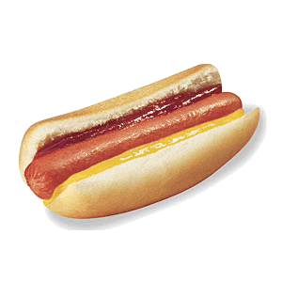 | When the order came for the second friend, she was glad it was a hamburger. But it was only a bun and meat, with a squirt of mustard and ketchup, that’s all! It met some of the success criteria but was far below her expectations. This server gets a 2.  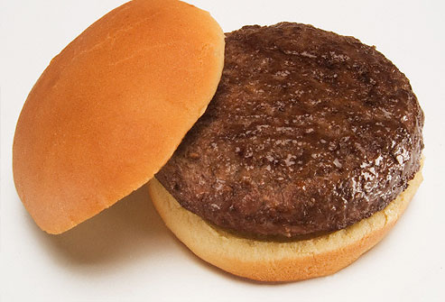 | When the third order came, the friend smiled. Here was the hamburger: fresh and hot, with all the fixin’s! This met all the success criteria. Without a doubt, it fully met expectations. This server gets a 3!  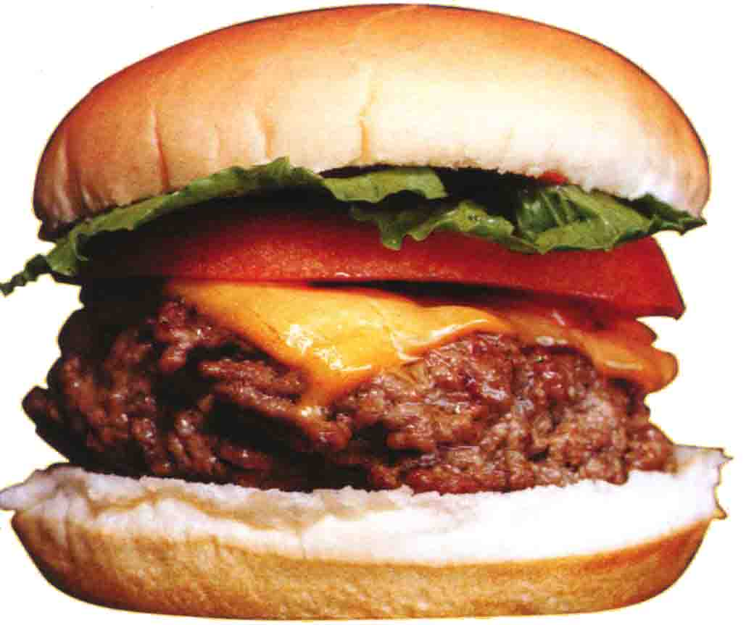 | When the fourth order came the friend was delighted! He’d got his burger, but the server had taken the time to add extras! This friend got more than he expected. It exceeded expectations and the server gets a 4!  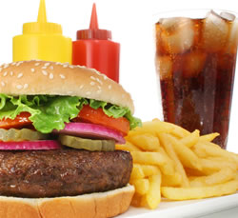
Adapted from The Leader in Me, by Stephan R. Covey, 2008

