MICROSOFT 365 Email
USER GUIDE

Contents
Frequently Asked Questions 3
What is Outlook Web/O365? 3
Accessing Outlook Web 3
Overview 4
What Else do I Need to Know About the Migration? 5
Page Layout Overview 7
Outlook Mail 7
Calendar 8
People (Contacts) 9
To-Do (Tasks) 10
Commonly Used Functions 11
Creating your email signature 11
Creating rules 12
Sending a new email 14
Creating a calendar item or meeting 15
Creating a new contact 16
Creating a To-Do task 18
Attaching documents, files and other emails 19
Viewing your calendar in the right pane 21
Create a group or distribution list 22

Frequently Asked Questions

What is Outlook Web/O365?

Outlook? O365? What is the difference?
Microsoft’s Office 365 is a subscription service offering an array of Office apps (Word, Excel, PowerPoint, Outlook) and Cloud storage. SD28 is decommissioning GroupWise for mail, calendars & contacts and migrating to Microsoft Outlook (part of the O365 Suite). Phase 1 of the migration will be to the Web version of Outlook.
Why are we migrating from GroupWise to Outlook?
School District #28 (Quesnel) is migrating to Outlook from GroupWise to move away from an unsupported platform and move into the future with a highly functional email platform.

Accessing Outlook Web

How do I access Microsoft Outlook on the Web?
- Open your web browser and navigate to https://outlook.office365.com/
- Enter your email address and click Next
- Enter your password and click Sign in
Can I access Outlook Web on my mobile device?
Yes; by following the same 3 steps above

Overview

What can I do with Outlook Web?
Outlook web is comprised of 4 main functions:
- Mail (Email)
- Calendar
- People (Contacts)
- To-Do (Tasks)

Mail (Email)
Send and receive email from personal and shared mailboxes. You can draft a new message, reply to a message and delete a message. You can view your Inbox, folders, Sent Items, Drafts and Deleted Items.

Calendar
View your personal and shared calendars. This includes appointments booked by you or meetings that others have invited you to.
People (Contacts)
Directory for personal and company contacts. Add your own contacts to a personal list or browse the company directory.
To-Do (Tasks)
To-do list, complete with notes, reminders, attachments, and the ability to share lists with others

What Else do I Need to Know About the Migration?

Mail Archives from GroupWise
For Phase 1 of the Migration, email archives will continue to be viewed through the GroupWise application

Booking Resources (meeting rooms)
For Phase 1 of the migration, meeting rooms will continue to be booked through the current process

Shared Mailboxes
To add a shared mailbox:
- Right-click the Folders button and select Add shared folder
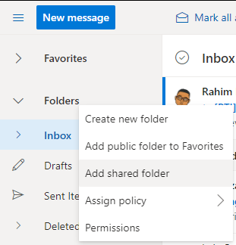
- Start typing the mailbox name or address. You may type the full email or select it from the list
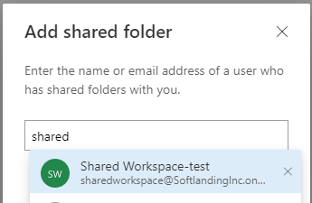

- Click Add
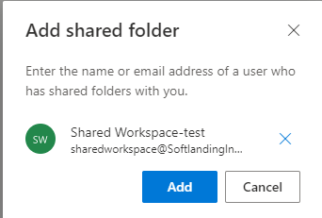

- You will now see it listed in the Folder pane. Click to view the Inbox and other mail folders for the shared mailbox
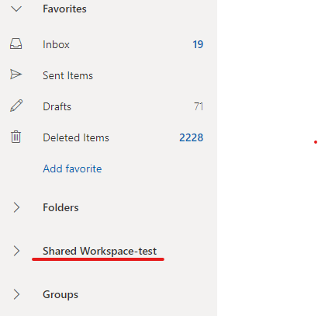

Please note, if you encounter the following error, you will need to reach out to the mailbox owner or IT support
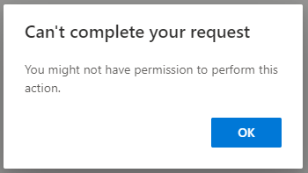

Page Layout Overview

Outlook Mail
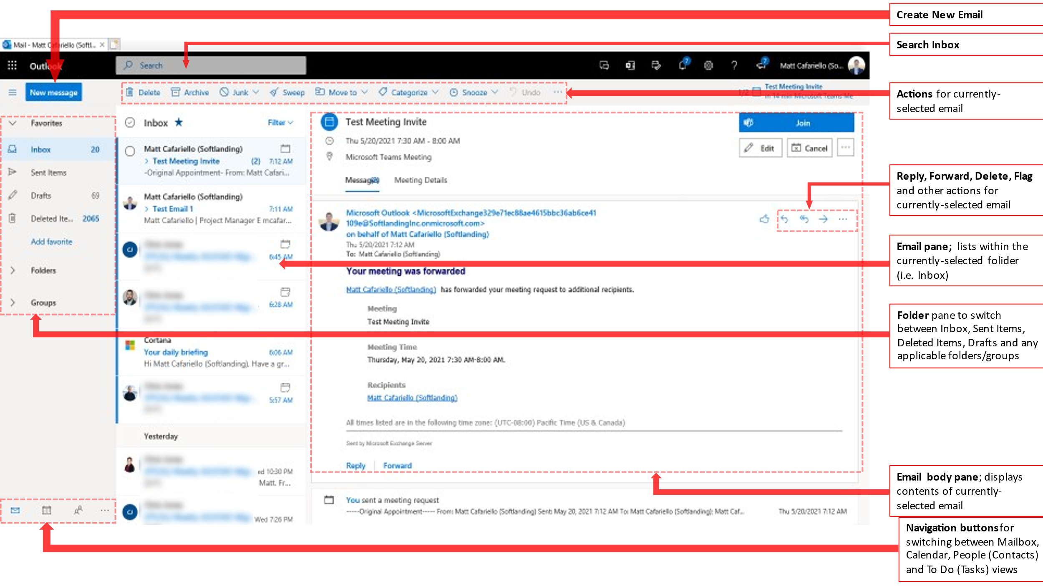
- The Mail page will be the initial view upon logging in to Outlook Web Mail.

- If you end up on the Calendar, People or To-Do pages and would like to return to Mail, simply click the button in the bottom left navigation button group

- A new email can be created by clicking New Message in the top left of the page.

- You can navigate between your personal mail folders and shared mailbox folders via the Folder pane on the left of the page.

- The middle Email pane displays the messages in your currently selected folder. In the screenshot above, the Inbox folder is selected.

- The Email body pane displays the currently selected email. In the screenshot above, this is the first email in the list on the Email pane. You can also reply, reply-all or forward an email by clicking the buttons in the top right of the message

Calendar
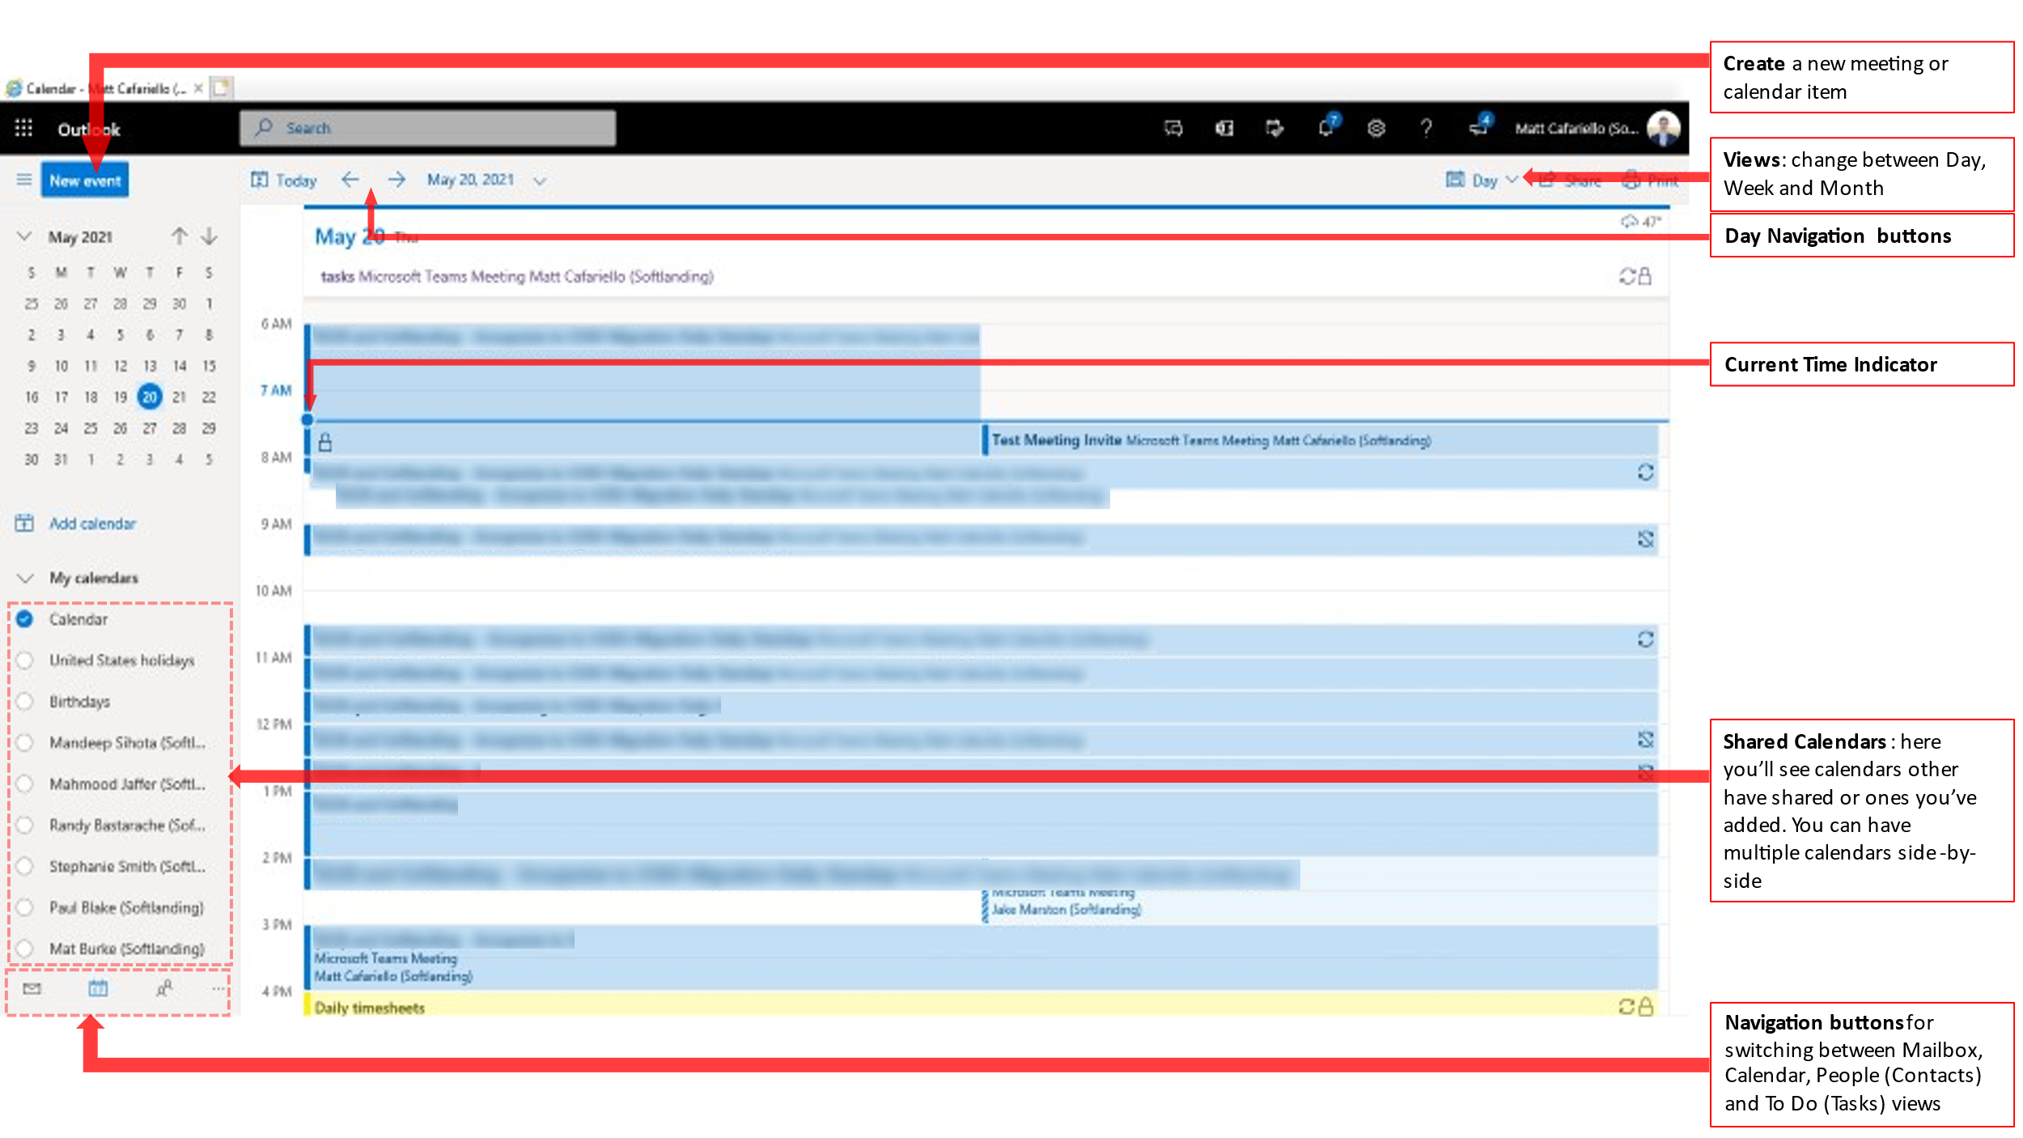
- The Calendar page can be accessed from any page by clicking the button in the bottom left navigation button group

- Meeting invites from colleagues and external contacts will automatically populate in your calendar. Unwanted calendar entries can be Declined and will be removed.

- Shared calendars can be accessed via the Add calendar button in the left pane.

- You can create a personal calendar entry or meeting invite by clicking the New event button in the top left of the page.

- Individual calendar entries can be double-clicked to see additional information (attendees, description, etc.).

People (Contacts)
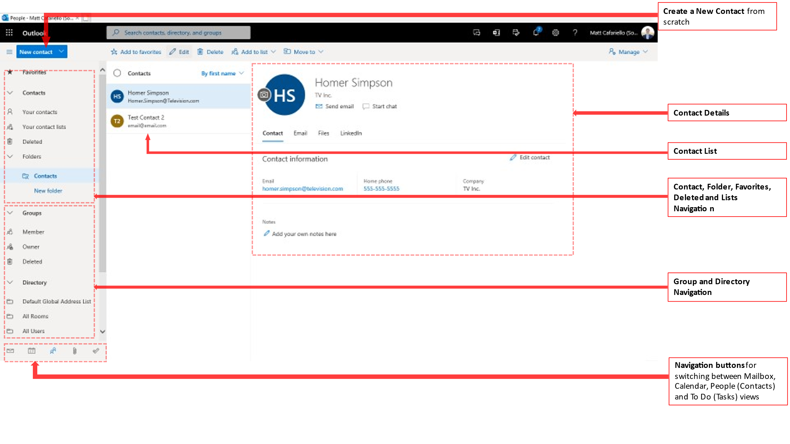
- The People page can be accessed from any other page by clicking the button in the bottom left navigation button group

- New People or Contacts can be added by clicking the New contact button on the top left of the page.

- People and Contacts from the currently-selected folder are listed in the middle pane.

- Click on a user in the middle pane to see their details in the right pane

To-Do (Tasks)
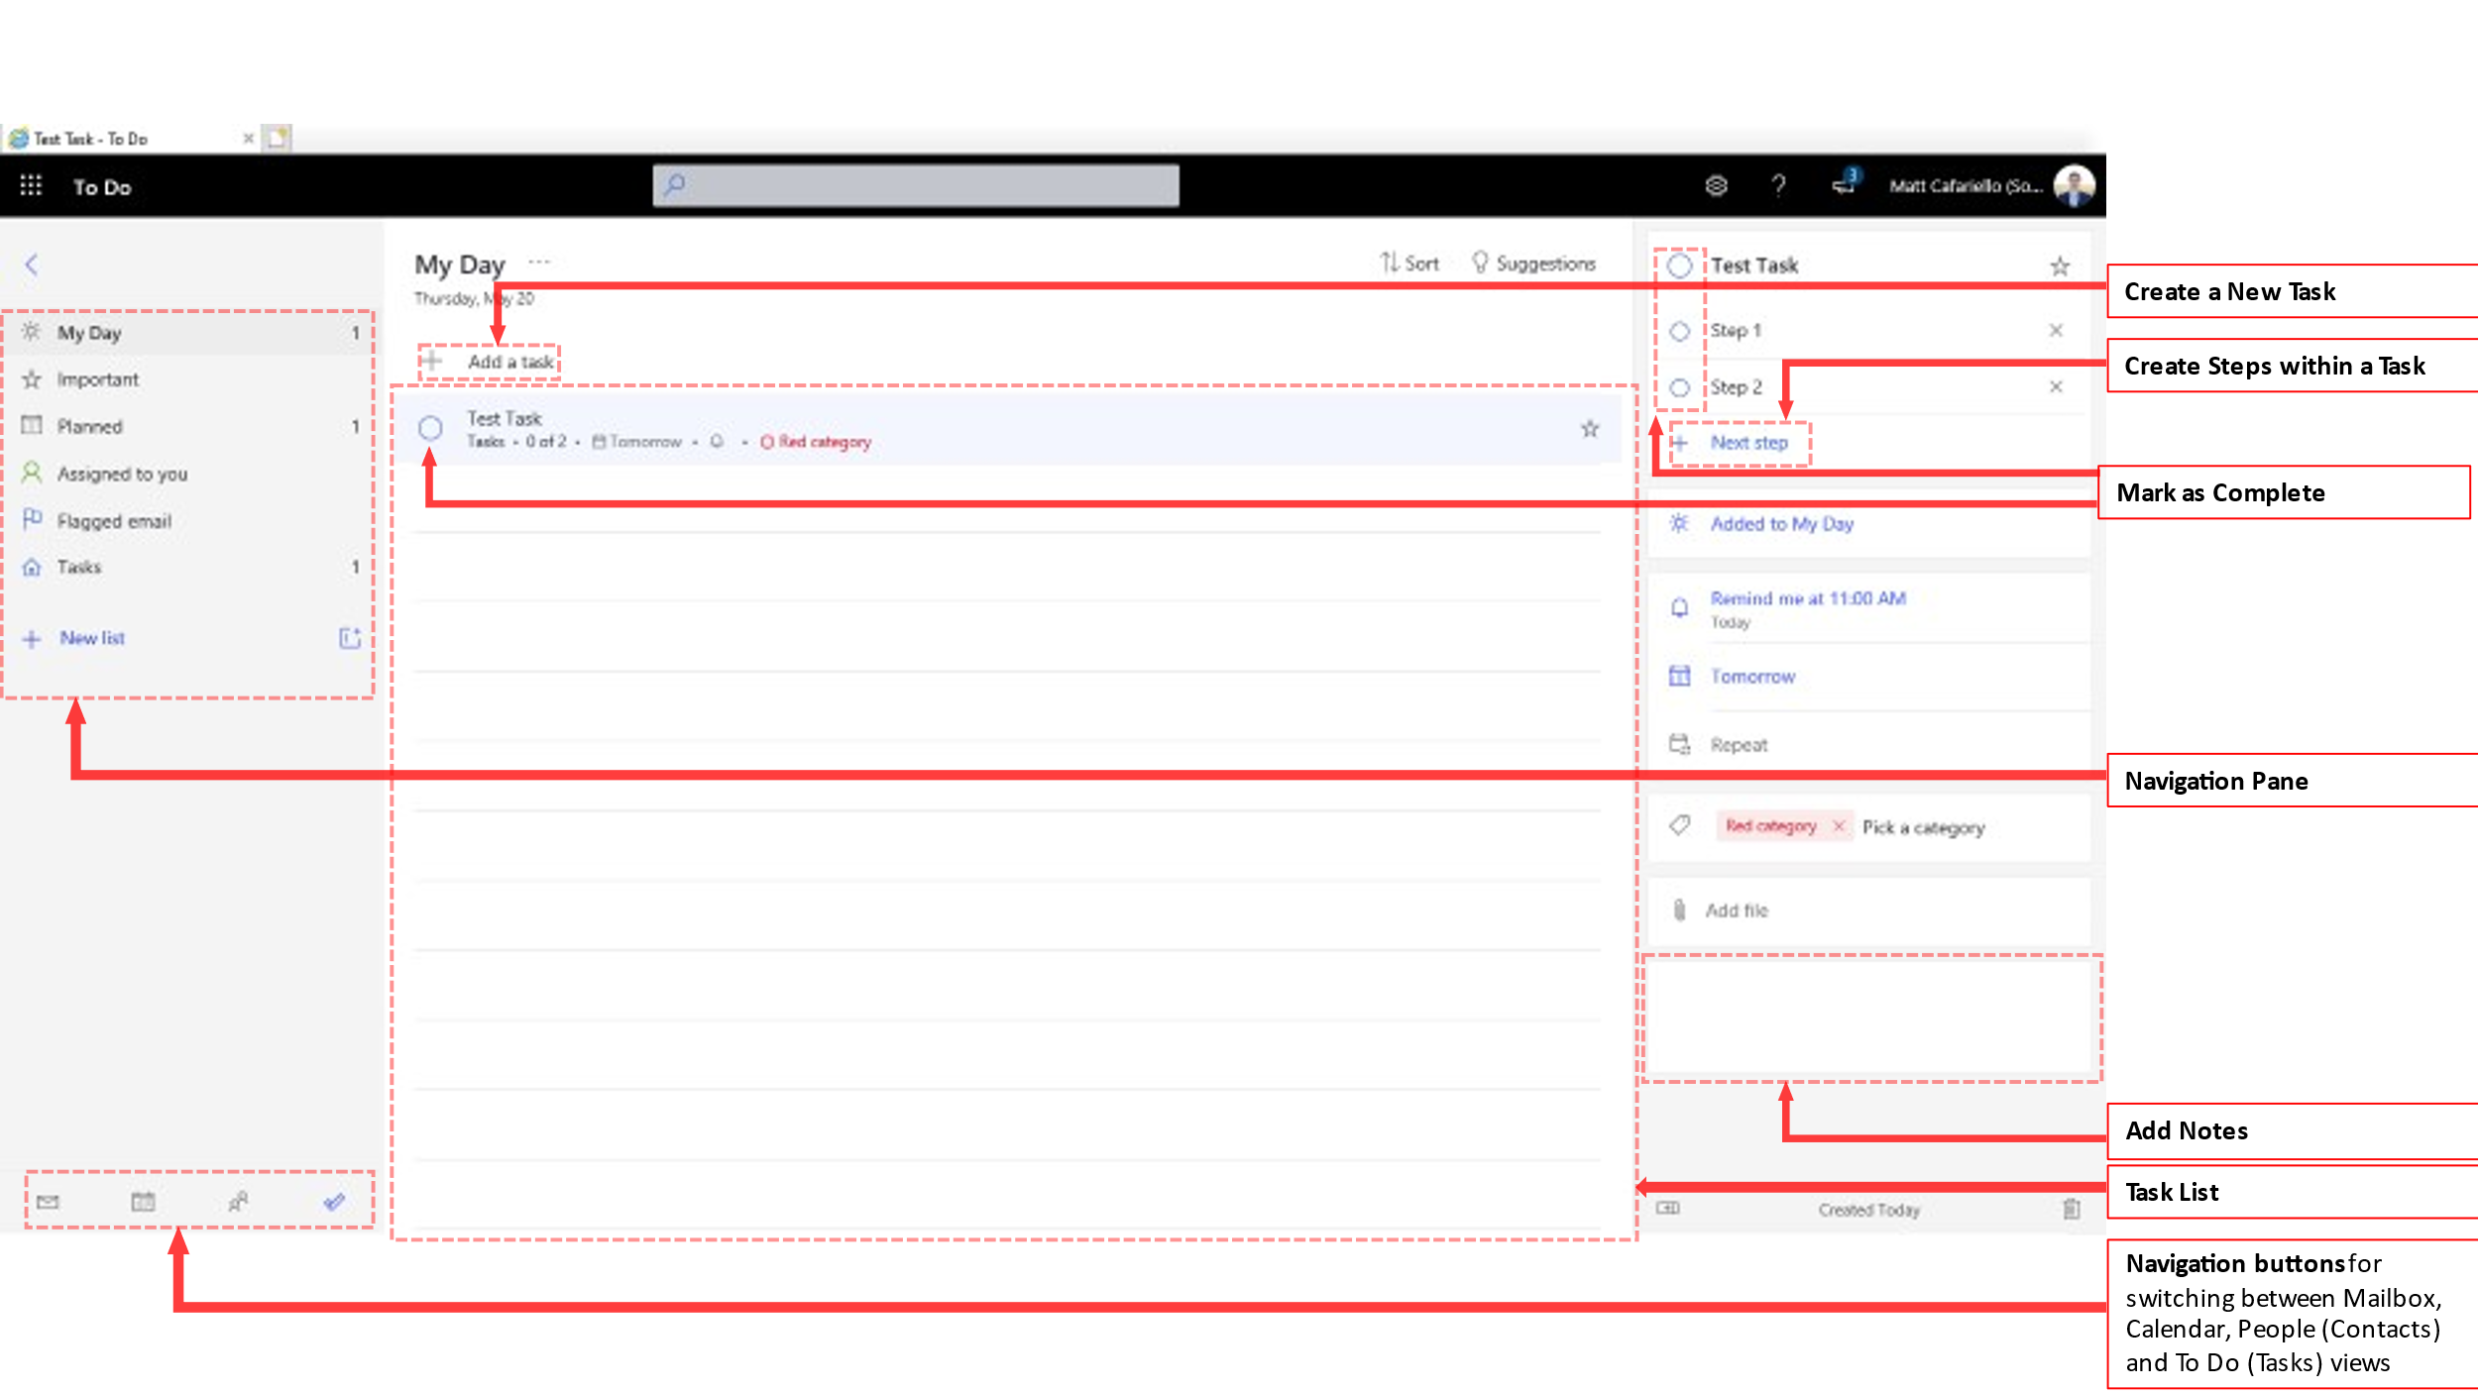
- The To-Do page can be accessed from any other page by clicking the button and then in the bottom left navigation button group.

- A new task or to-do item can be added by clicking the Add a task button in the top left of the page.

- Steps within the task can be created by clicking Next step in the top right of the page.

- Task reminders can be set via the middle section of the pane on the right of the page (i.e. Remind me at…)

- File attachments and additional notes can be added in the area on the bottom right of the page.

Commonly Used Functions

Creating your email signature
- From any page within Outlook Web, click the button in the top-right of the page
- Type ‘signature’ in the search box and click Email signature
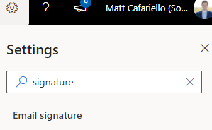
- Type and format your email signature in the box that appears. Select the check-boxes and settings that you would like to apply to your signature.
- When complete, click Save at the bottom right of the page.
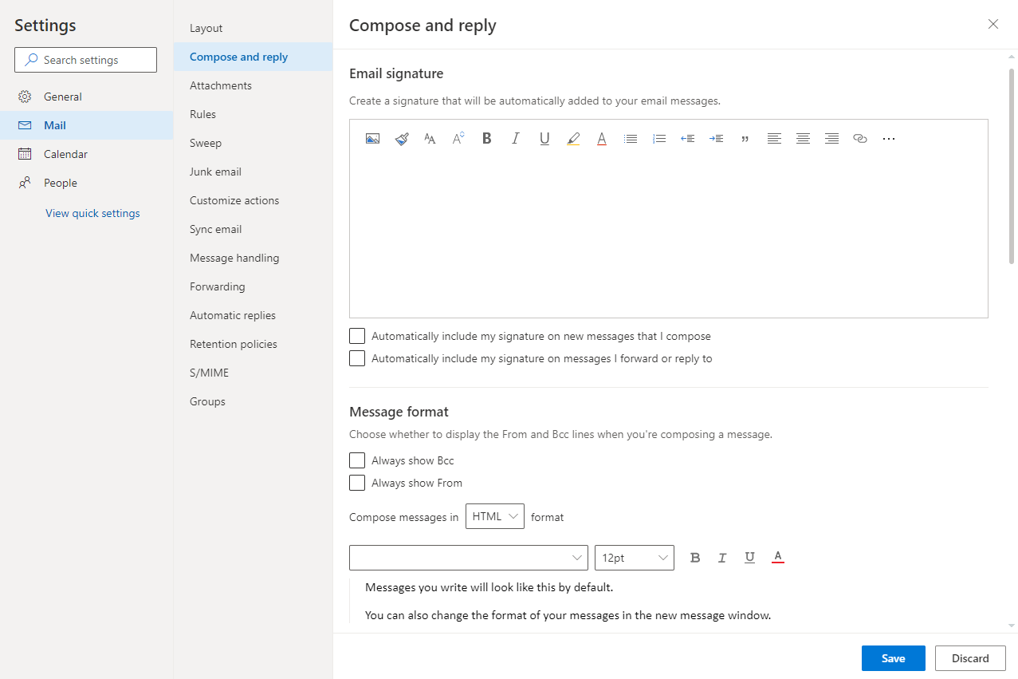

Creating rules
- From any page within Outlook Web, click the button in the top-right of the page
- Type ‘inbox rules’ in the search box and click Inbox rules in the list below
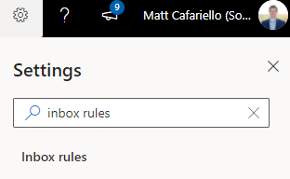
- The next screen will display all current rules and allow you to create new ones
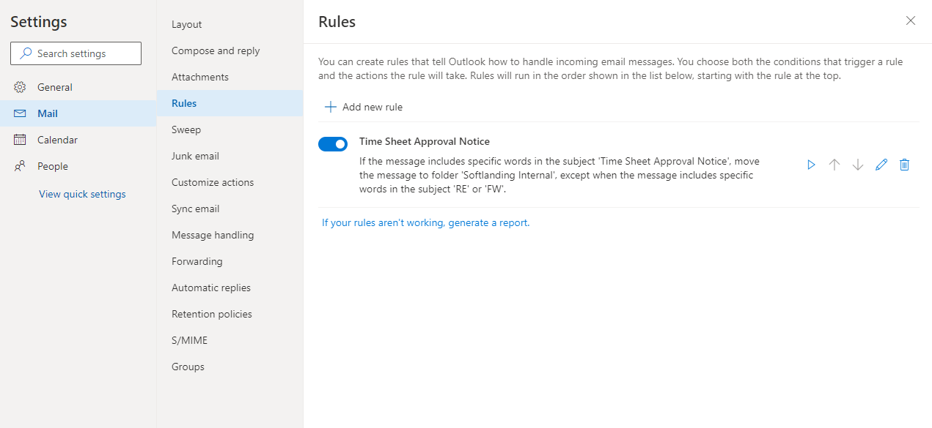
- To add a new rule, click
- Type a name for the rule
- Click the drop-down to add a condition
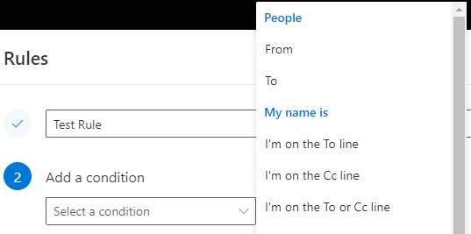

- Click the drop-down to add an action
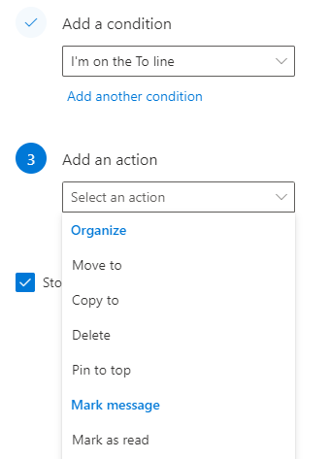
- Some options will create additional menus if applicable. For example, clicking ‘Move to’ will then add an additional box to specify which folder to move the email to
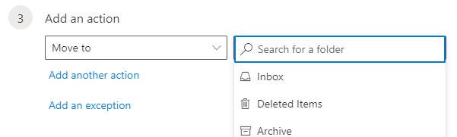
- Multiple Conditions and Actions can be applied to the rule via the Add another condition and Add another action buttons
- Exceptions to the rule can also be configured by clicking Add an exception
- Check or un-check the box to Stop processing more rules as appropriate. Please click the button to view a detailed description of this function from Microsoft
- Click Save

Sending a new email
- Ensure you are on the Mail page by clicking the button on the bottom left of the page
- Click on the top left of the page
- The new email window will appear in the right pane
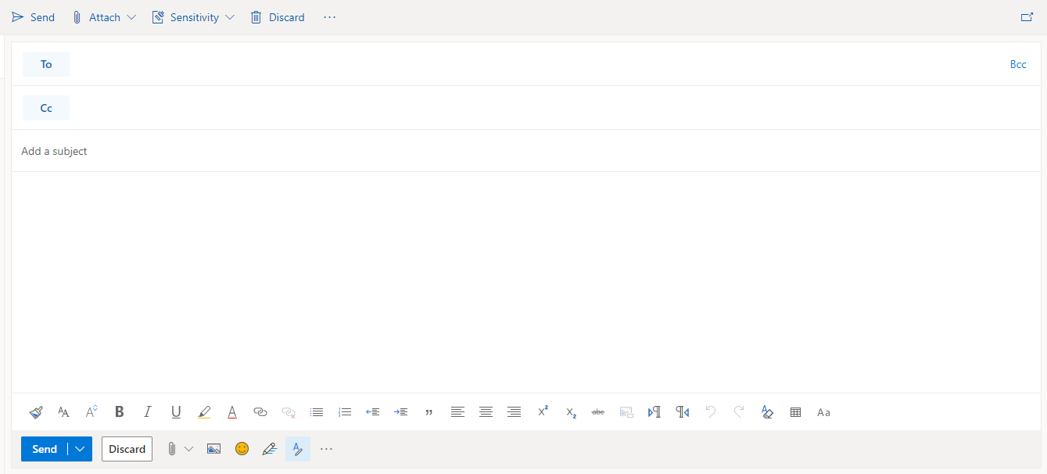
- If desired, the new email can be opened in a new window by clicking the button in the top right of the page
- Add the recipients to the To and Cc fields as appropriate.
  - Bcc is also possible by clicking the Bcc button in the top right of the window
- Type a subject in to the Add a subject field.
- Type your message in the large message body box below the subject field.
- Text formatting can be applied via the bar below the message body (similar functionality to other Microsoft Office applications)
- Attachments, photos and emojis can be inserted via the buttons on the bottom bar 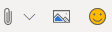
- When you are ready to send your message, click Send

Creating a calendar item or meeting
- Ensure you are on the Calendar page by clicking the button on the bottom left of the page
- Click the button
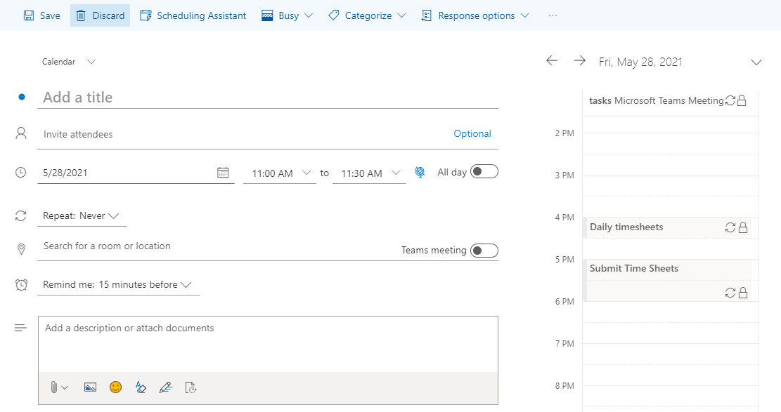
- Enter a title for the meeting in the Add a title field
- Enter invitees in the Invite attendees field if applicable.
  - This is optional. Leave this blank if you are just creating an item for your personal calendar
  - If you are inviting others, you can quickly see their availability via the button
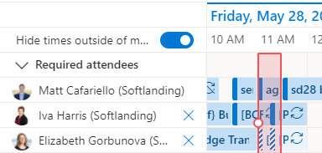
- Select the date and time of the meeting via the drop-down menus
  - If this is an all-day meeting, click the slider
- Set recurrence if applicable by clicking the Repeat dropdown
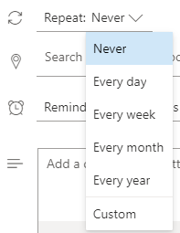
- Enter the location (this can simply be entered as free text)
- Select when you would like Outlook to remind you of the event via the Remind me drop-down
- Add a description, attachments, photos or emojis via the Add a description or attach documents box.
- Click or
  - The Save button will appear if you have not invited anyone to the meeting (step 4)
  - The Send button will appear if you have invited others to the meeting (step 4)

Creating a new contact
- Ensure you are on the People page by clicking the button on the bottom left of the page
- To manually create a new contact:
  - Click
  - Enter the person’s information in the window that appears
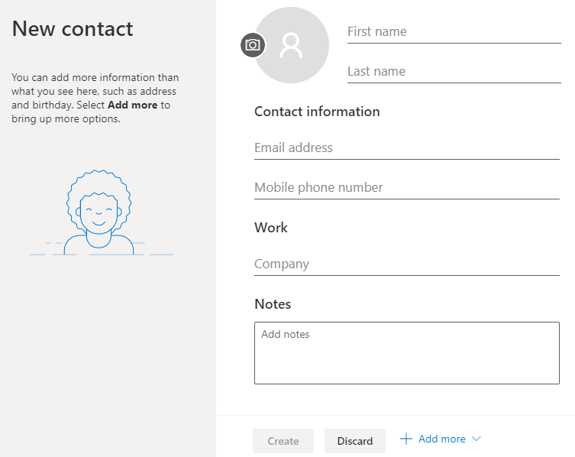

  - Additional data fields can be added by clicking the button
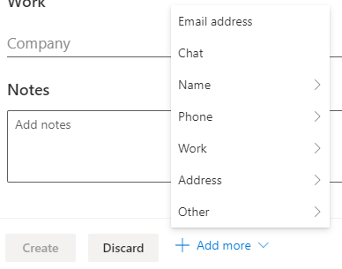
  - Click to finish

- To add a contact via your company directory:
  - Select the appropriate list from the Directory drop-down on the left pane
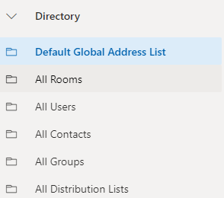
  - Select the contact from the list to view their details
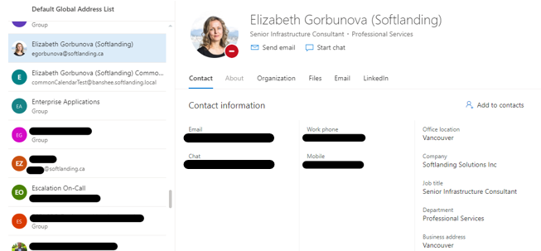
  - Click the button to the right of the contact details

  - Modify or add detail as required. Any changes will only apply to your personal contact list
  - Click Create
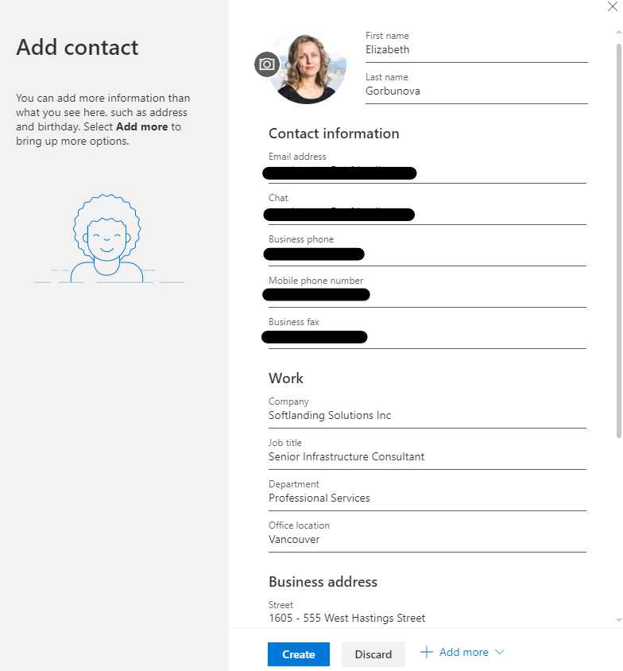

Creating a To-Do task
- Ensure you are on the To-Do page by clicking the button on the bottom left of the page
  - This button may be hidden. If so, first click the ellipses
- Click Add a task
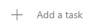
- Type the task title
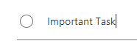
- Press Enter on your keyboard

- Click on your new task to view additional data fields on the right of the page
- Click the applicable fields to add Steps, reminders, due dates, categories, file attachments and notes as required.
- A task can be flagged as important by clicking the button
- Lists and tasks assigned to you can be viewed via the left navigation pane
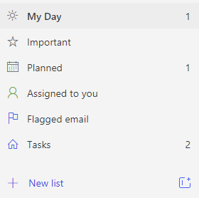

Attaching documents, files and other emails
- Ensure you are on the Mail page by clicking the button on the bottom left of the page
- Create a new message or open an existing message from your inbox and select either reply, reply-all or forward

- An attachment, including a document, email or any other type of file, can simply be ‘dragged and dropped’ into the email message
  - To attach another email:
    - Click and drag the email from your inbox to your message
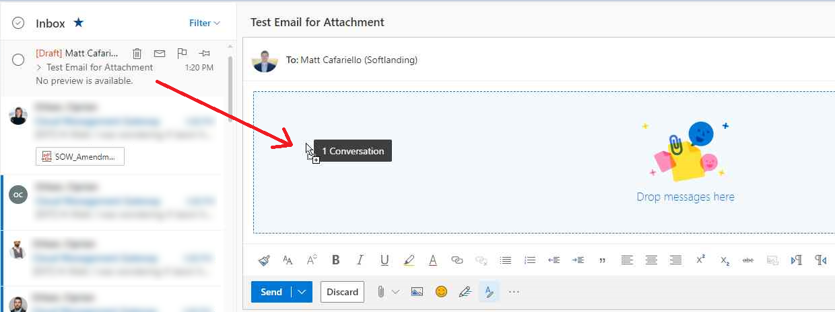
    - You will now see it attached just below the recipient name
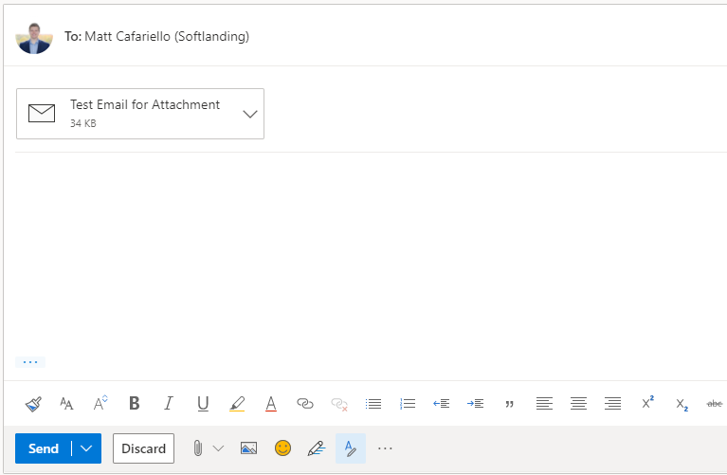
  - To attach a file or document:
    - Click the button
    - Click Browse this computer
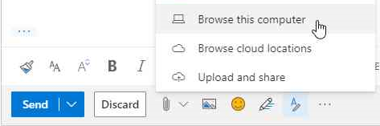
    - Navigate to the file that you would like to attach
    - Double-click the file or click the file and click Open
    - You will now see it attached just below the recipient name

Viewing your calendar in the right pane

- Please note that these steps can be completed from either the Mail, Calendar or People pages.
- In the top-right of the page, click the button
- Your calendar will now appear in the pane to the right of the page
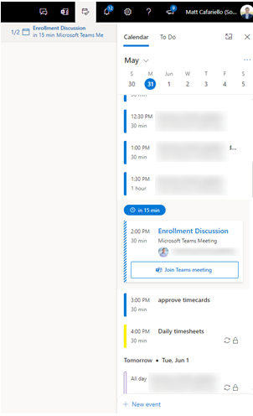
Note: To pop out the calendar from the side pane to full screen, click the button in the top-right

Create a group or distribution list
- Ensure you are on the Mail page by clicking the button on the bottom left of the page
- In the left pane, right-click on Groups
- Select New Group
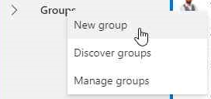
- Enter a name, email address and description for your new group
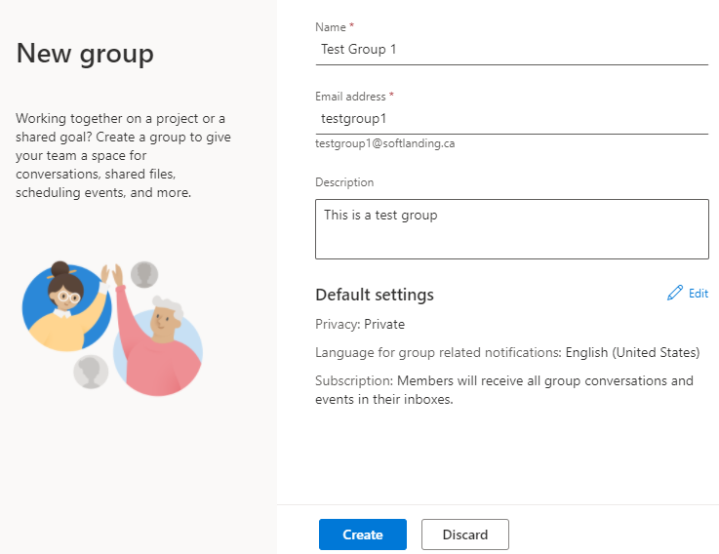

- To modify the permissions, click
  - Select the options applicable to your new group
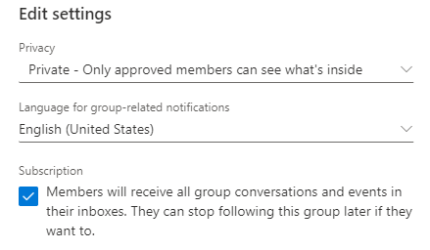

- Click
- Type in the names or emails of colleagues that you would like to add to the group. Depending on your organization’s IT policy, some types of addresses may be restricted
