Orange Shirt Story Phyllis (Jack) Webstad
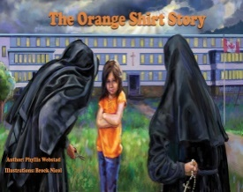 | 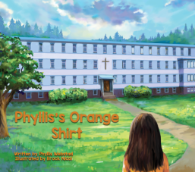 | 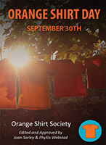 | Next Book:  Her true story of being at St. Joseph’s Residential School

Every Child Matters’: Residential school survivor Phyllis Webstad explains Orange Shirt Day https://www.citynews1130.com/video/2020/06/18/every-child-matters-residential-school-survivor-phyllis-webstad-explains-orange-shirt-day/
Phyllis gets her first book in the mail: https://www.facebook.com/watch/?v=973478472834687
PHYLLIS’ Story: The Original orange shirt https://www.sd57.bc.ca/school/abed/Documents/Orange%20Shirt%20Day.pdf
The Orange Shirt Story (links to printable resources K-12) https://www.orangeshirtday.org/
- Orange Shirt Day Activities – BCTF https://bctf.ca/uploadedFiles/Public/AboriginalEducation/OrangeShirtDayActivities.pdf
- Orange Shirt day Activities – K-12
Orange Shirt Day – CBC Kids News https://www.youtube.com/watch?v=K3uP90IXvAE
CBC News – What Orange shirt Day Means Toronto https://www.youtube.com/watch?v=o3P3TzGpicA
Hearing from students https://www.youtube.com/watch?v=yWY9f6TItFw
Remember | Recover | Reconcile

Survivors Story: Eddy Charlie https://www.youtube.com/watch?v=vzAqaTjNLQU

Book Launch: Medicine Wheel Education
*You are invited to the Orange Shirt BOOK LAUNCH - September 16, 10 am PST
https://medicinewheel.education/pages/osdbooklaunch?fbclid=IwAR1W0hHb6GPJOGcZNwhMcHxyZgrCCWsEpw6XXK0uvpVlPuGk97x5T5Ari8Q

From the Desk of Aboriginal Education/Holli Garvin 2020 - 2021

