CAREER EDUCATION BIG IDEA 3:
Leadership requires listening to and respecting the ideas of others.
Competencies | Learning Opportunities | Portfolio Activity
Curricular  - Defining  - Ideating  - Prototyping  - Testing  - Making  - Sharing  - Use materials, tools, and technologies in a safe manner, and with an awareness of the safety of others, in both physical and digital environments  - Use familiar tools and technologies to extend their capabilities when completing a task  - Choose appropriate technologies to use for specific tasks  Core  - Communication  - Creative Thinking  - Critical Thinking  - Social Responsibility | In groups, have students complete a critical challenge. Using only the supplies provided (pipe insulation, painter’s tape, marble etc.), have the groups work together to create a “Moana” roller coaster having a minimum of 2 hills, a loop and a banked curve that a marble can travel the entire distance.  Have students brainstorm before they select any supplies. Have them draw different options and select the one they want to try. Then have them choose their materials and start creating.  Prototypes will need to be tested, adjusted and tested again until they can achieve the goal (or come reasonably close!).  Plan different critical challenges throughout the year so that all students have a chance to be the “project lead”. | Reflection  - Discuss your experience working with a team to build a product  - Was it hard to hear everyone’s ideas?  - Did you use everyone’s ideas?  - How did you select which ideas to use?  - How many different ideas did you draw out?  - Did your first idea work?  - How did you have to adjust your creation after trying it the first time?  - What have you learned about creating things and the importance of a plan?  - Use the core competency self-assessment to reflect on growth of these competencies
Cross-curricular integration:
ADST; Sciences (Gr 5) Students are expected to know properties of simple machines and their force effects; Applying & Innovating curricular competency (cooperatively design projects; generate and introduce new or refined ideas when problem solving)

ADST Creative Process

Competency | Process Description
Empathizing/ Understanding context | - Identifying the goal, plan and reason for the project  - Find potential design and leadership opportunities
Defining | - Consider parameters and size of the creation  - Work together to decide how everyone will be involved with the project
Ideating | - Generating potential ideas (brainstorming with group – blueprint ideas)  - Select a potential idea to blueprint
Prototyping | - Create a blueprint sketch with labels and descriptions  - Build the model according to design specifications
Testing | - Test with the marble to determine what changes need to happen  - Troubleshoot and make any necessary changes  - Gather feedback from group members and other peers for further inspiration
Making | - Refine product design to ensure compliance with and making efforts to exceed stated minimum criteria (1 loop, 2 hills and a banked curve)  - Make adjustments to the blueprint drafts to reflect changes in design  - Use materials in ways that minimize waste and maximize durability and efficiency.
Sharing | - Submit final blueprints and project for presentation  - Demonstrate and explain design to class/ audience  - Evaluate product based on criteria and expectations  - Reflect on learning process and group collaboration (core competency self-assessment)

Core competency focus Name: ______________________

Communication  -I have ideas & opinions that I share with my classmates in a respectful way | Thinking (Creative/ Critical)  -I can build on other people’s ideas and add my own ideas to create something new  -I realize my ideas may not always be successful, but I can learn from my mistakes to move forward, even with several tries. | Personal Awareness/ Social Responsibility  -I can show respect and include others. I accept differences in others.  -I am kind to others, can cooperate and build positive relationships.

Insert drawing/ picture/ evidence:  In conclusion, I have shown growth through this project by: | 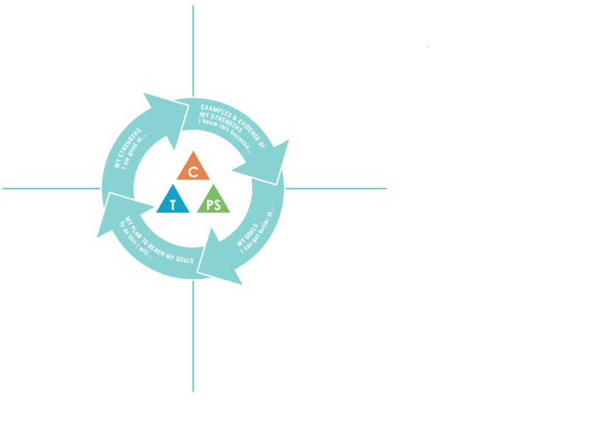

Project Self-Evaluation
 | Exemplary | Accomplished | Developing | Beginning
Finished Product | The marble easily travels over more than two hills, more than one loop and/or more than one banked curve to reach its destination. | The marble easily travels over are two hills, a loop and a banked curve to reach its destination. | The marble does not consistently travel the distance of two hills, a loop and banked curve OR one of the requirements is missing. | The marble cannot travel the distance of two hills, a loop and banked curve OR more than one of the requirements is missing.
Blueprint design | The blueprint provides detailed explanation of the design with labels and attention to quality. | The blueprint provides detailed explanation of the design. | The blueprint does not give a full explanation. | The blueprint is incomplete or missing.
Creativity | The design and product demonstrate a unique or novel approach to roller coaster design. Materials are used to ensure maximum durability and efficiency but minimizing waste. | The design or product demonstrates a unique approach to roller coaster design. Materials are used to maximize efficiency but minimize waste. | The design or product demonstrates some originality to roller coaster design. Materials are used to minimize waste and some attention to efficiency. | The design or product demonstrates little originality to roller coaster design. Materials are wasted and little attention to efficiency or durability.
Communication & collaboration | The team worked well together with members being responsible for their own part. I worked well to achieve my role and helped other group members. Every team member encouraged each other in the process. | The team worked together with members being responsible for their own part. I achieved my role and sometimes helped other group members. Most team members encouraged each other in the process. | The team sometimes worked well together with most members being responsible for their own part. I usually achieved my role. Some members encouraged each other in the process. | The team did not get along. I had difficulties achieving my role. There was no encouragement from members of the team.

