Core Competencies: A Practical Guide

Curriculum Better Practice Series
Workshop #2 of 5

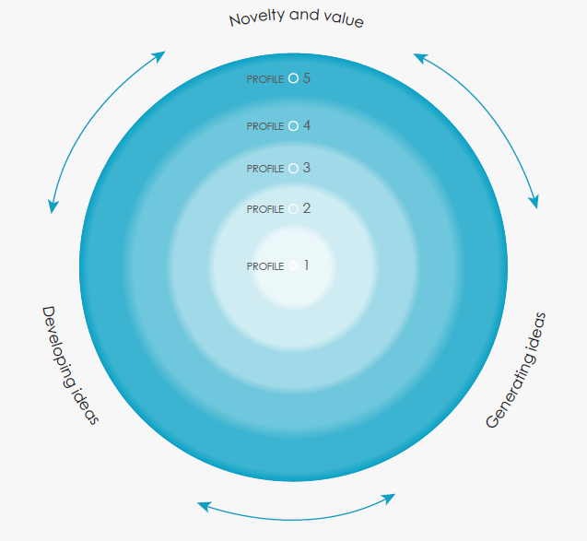

Hosted by SD57 Curriculum Coaches
Deneen Sawchuk, Tamara DeFord, Shay Jones, Lauren Stelmaschuk, and Sherrie Pearce

Core Competencies Summary
Competency | Description | Facet
Positive Personal & Cultural Identity  PS | The positive personal and cultural identity competency involves the awareness, understanding, and appreciation of all the facets that contribute to a healthy sense of oneself. It includes awareness and understanding of one’s family background, heritage(s), language(s), beliefs, and perspectives in a pluralistic society. | - Relationships and cultural context  - Personal values and choices  - Personal strengths and abilities
Personal Awareness and Responsibility  PS | Personal awareness and responsibility includes the skills, strategies, and dispositions that help students to stay healthy and active, set goals, monitor progress, regulate emotions, respect their own rights and the rights of others, manage stress, and persevere in difficult situations. Students who demonstrate personal awareness and responsibility demonstrate self-respect and express a sense of personal well-being. | - Self-determination  - Self-regulation  - Well being
Social Responsibility  PS | Social responsibility involves the ability and disposition to consider the interdependence of people with each other and the natural environment; to contribute positively to one’s family, community, society, and the environment; to resolve problems peacefully; to empathize with others and appreciate their perspectives; and to create and maintain healthy relationships | - Contributing to community and caring for the environment  - Solving problems in peaceful ways  - Valuing diversity  - Building relationships

Creative Thinking  T | The creative thinking competency involves the generation of new ideas and concepts that have value to the individual or others, and the development of these ideas and concepts from thought to reality. | - Novelty and value  - Generating ideas  - Developing ideas
Critical Thinking  T | Critical thinking involves making judgments based on reasoning: students consider options; analyze these using specific criteria; and draw conclusions and make judgments. Critical thinking competency encompasses a set of abilities that students use to examine their own thinking, and that of others, about information that they receive through observation, experience, and various forms of communication | - Analyze and critique  - Question and investigate  - Develop and design
Communication  C | The communication competency encompasses the set of abilities that students use to impart and exchange information, experiences and ideas, to explore the world around them, and to understand and effectively engage in the use of digital media.  Communication competency provides a bridge between students’ learning, their personal and social identity and relationships, and the world in which they interact. | - Connect and engage with others (to share and develop ideas)  - Acquire, interpret, and present information (includes inquiries)  - Collaborate to plan, carry out, and review constructions and activities  - Explain/recount and reflect on experiences and accomplishments

Step Plan
Step 1 - Explicit Teaching – Tell
Teachers help students understand Core Competencies by giving definitions, explanations, and examples of competencies.
Step 2 - Student Prompts – Ask
Teachers have students think about the Core Competencies by giving prompts, asking questions, and helping them notice their behaviours.
Step 3 - Student Mini-reflections and self-assessments
Student activity reflection, ticket out the door, Dear Etiquette Expert Cards, etc,
Step 4 - Data Gathering
Exemplars and examples store in a file folder, on fresh grade, or in a special binder. Student controlled, teacher supported.
Step 5 - End of year Student Self-Assessment and “Celebration”
Students take their “data” and pour it onto the floor. They pick their “three best, three most recent exemplars” and use them as talking points for self-assessment. Reflect, celebrate, and make a plan.

Step
C

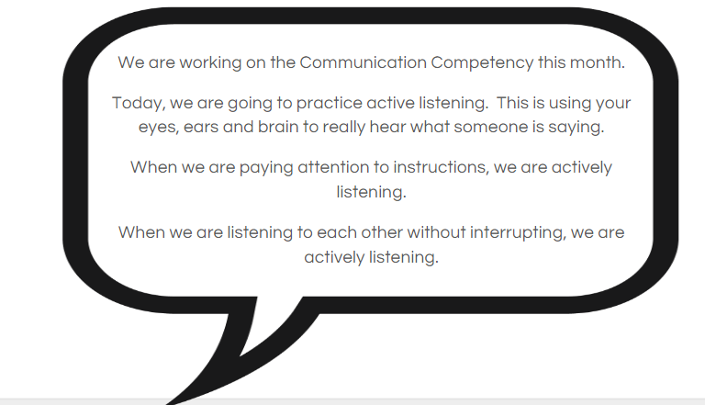

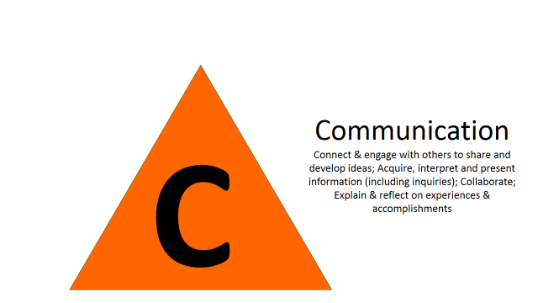

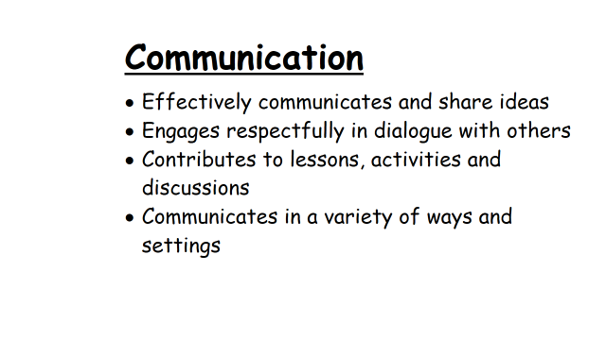

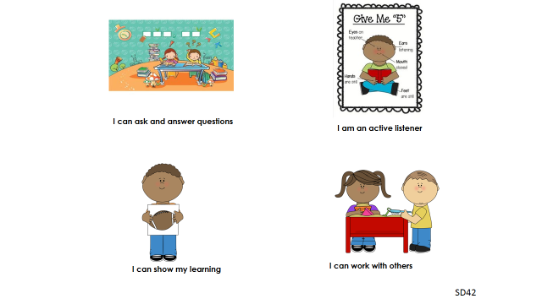

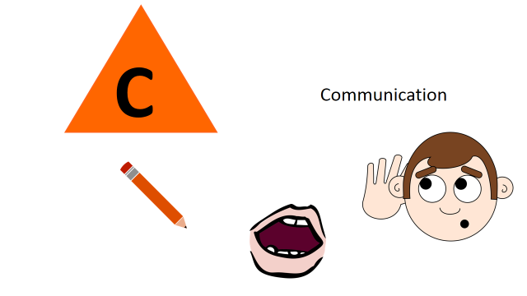

To have the students think about the Communication Core Competency, teachers might say to students….
When you gathered basic information
When you listened to peers
When you encouraged others to speak
When you recounted others’ ideas
When you helped move a conversation forward
When you expressed yourself clearly in written, verbal, or artistic ways
When you helped the group come to consensus
When you answered questions clearly
C

To have the students think about the Personal and Social Core Competency, teachers might say to students….

PS

Positive Personal and Cultural Identity

In your groups I saw you problem solving
You included others in your group and worked well with them
You thought carefully before acting or reacting
You compromised
You listened and respected another opinion
In science we looked at other worldviews
In socials we looked at how the past
When we looked at this story, what did you notice about…
You acted like a leader.
You were a respectful follower
You are able to identify what you did well
You know your strengths and are
You helped someone else.
You included others
Social Responsibility
Personal Awareness and Responsibility
To have the students think about the Thinking Core Competency, teachers might say to students….
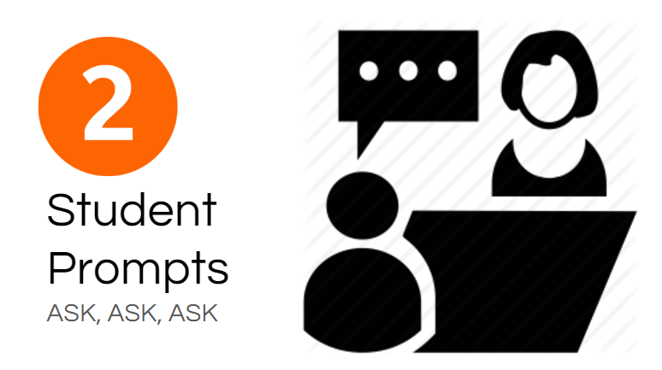
T
Critical
When you finally landed on the best plan
When you looked at all the possible solutions and decided which would work best
When you discarded an idea or design that you didn’t think would work
You are able to analyze data
You can look at graphs and determine which the most likely explanation is
You can read a novel and discern what a characters motivations were
You can look at rules for the game and follow them because they make sense to you from a strategic point of view
you are able to decide what strategies work best for you in different situations
you can see the root of the problem
Creative
Brainstorming without judgment
Working off of another’s idea
Having an original idea
When you tried to figure out ways to include everyone
When you combined several ideas
When you visualized several ways of solving the problem
When you came up with a story line or a project topic
You can look at a graph and come up with 5 possible explanations for the data (even if some are whacky)
When you tried 5 or 6 different ways to solve something
You played and developed ideas
Step

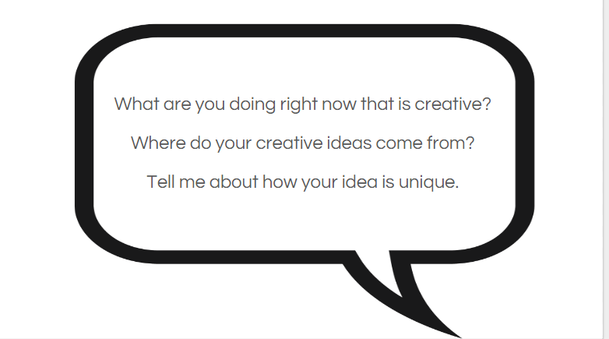

Activity “Step 2 – Student Prompts” – some examples from SD 42 Workshop
Communication
How do you share information with others?
Can you describe some ways you have collaborated with others?
How do we communicate effectively: looks like, sounds like, feels like?
How do you show you are an active listener?
What is my role in group work?
How do I connect an engage with others?
What is your strength in group work?
Who do you read to?
What role is easy for you, hard for you?
How do I acquire/interpret/present information? (focus on one at a time)
What is the purpose of collaboration?
Think of a time when you presented to others. What worked well/was important to do?
Think of a metaphor that shows who you are as a listener/learner/communicator?
What could you do differently? (Know what you know about what you do differently)

Critical Thinking
Tell about a time when you had to try more than one strategy to solve a problem.
What strategy did you use to analyze ideas?
Can you give an example of …?
Why do you think …?
How do you solve ….?
Can you explain …?
Can you elaborate on the reason …?
Tell me about the time you used multiple sources to get information.
How did you decide if they were real/true/accurate?

Creative Thinking
Where do your new ideas come from?
What do you do with your new ideas?
Describe a time when you helped build upon the ideas of others.
Describe the environment that works best for you when creating ideas.
Describe a time when your ideas took a long time to develop.

Personal Awareness and Responsibility
What treasures or gifts do you bring to our class?
When I am having trouble with something I …
What storybook characters remind you of yourself?
What do you need so that you can contribute to our class discussions?
When I get upset I …
I know I am good at this because …
I keep myself healthy by …
These events _________ helped me to grow by …

Positive Personal and Cultural Identity
What makes you unique?
Tell me about your learning strengths.
How do you learn best?
Who are you? I am …
What makes your heart sing?
What is most important to you?
How do you make good decisions?
What influences your decisions?

Social Responsibility
I use kind words and actions to encourage and or help others when…
It is easiest to work cooperatively with others when …
Tell me how you encourage others to understand the importance of community and/or world events and how they relate to us.
Explain to me how you look for ways to help make the lives of others better. How do you take action?
Tell me about a time when you planned ways to take care of environment. How could you encourage others?

Step
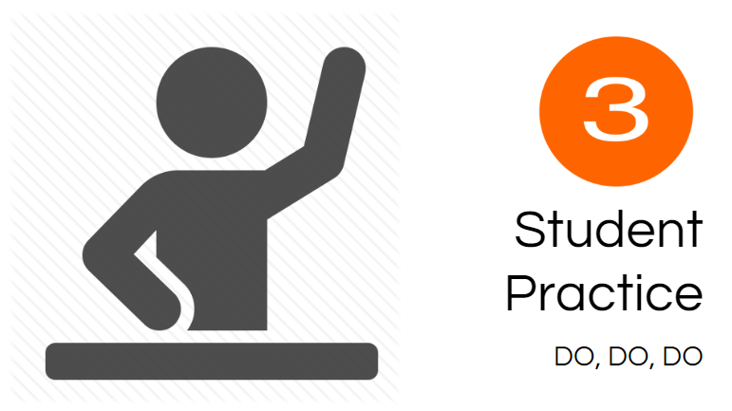
Students practice self-assessment and reflection
- Ticket-out-the-door
- Core Competency assessment sheets
Students get a chance to think about and practice skills.
- Dear Etiquette Expert

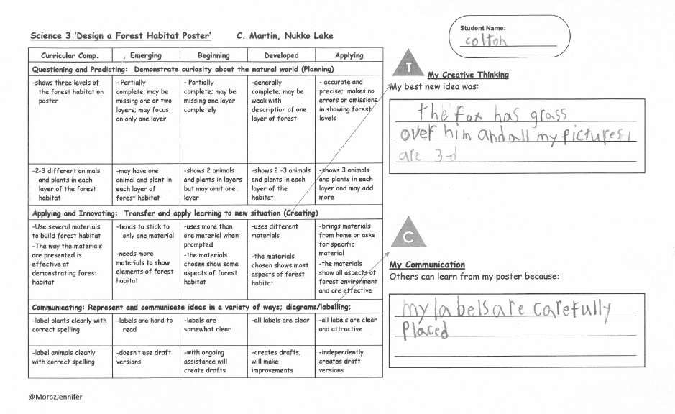
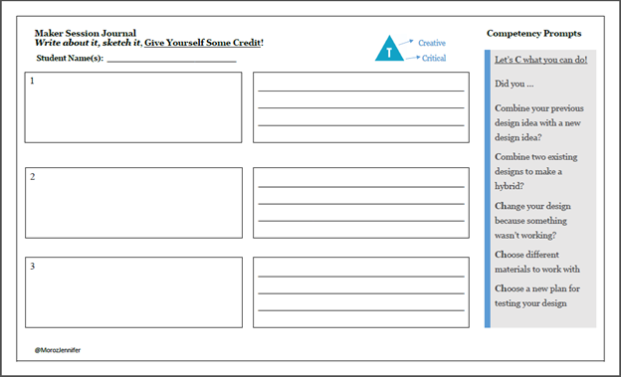
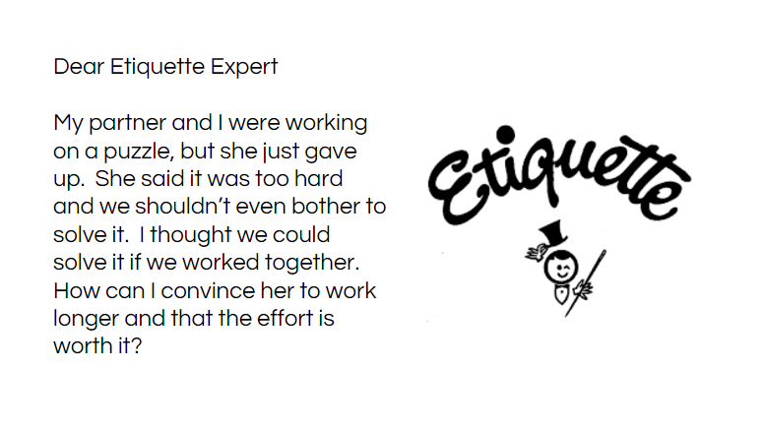

CRITICAL THINKING Self-Assessment
Think back to the four investigative activities from this unit: 1A The Effect of Concentration on Reaction Rate; 1B The Effect of Temperature on Reaction Rate; 1C How Temperature Affects Exothermic vs Endothermic Reactions; 1D Changing the Catalyst in a Reaction. Look through your lab write-ups if they are available to you. Try to find examples where you used the following science thinking skills. (You do not need to find an example of every skill from every activity.)

 | Analyze and Critique  - Identify criteria to use when analyzing evidence.  - Analyze evidence from different perspectives. | Question and Investigate  - Ask open-ended questions and gather information.  - Differentiate between facts and interpretations. | Develop and Design  - Experiment with different ways of doing things.  - Develop criteria for evaluating design options
1A
1B
1C
1D

Step

Students should be responsible for this as much as possible.
Teacher intervention if file folder is too empty or too full.
Mark with a note as to why it is good evidence (colour triangle/Letters ‘C’, ‘T’, ‘PS’)

Step
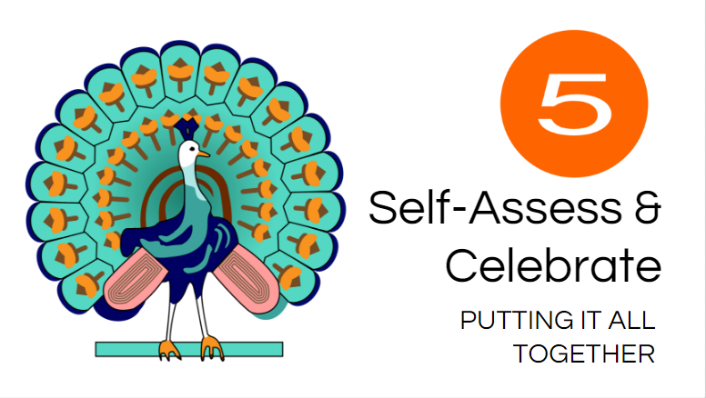

For example:
What are you proud of?
What are you good at?
How do you know?
What will you work on next?

